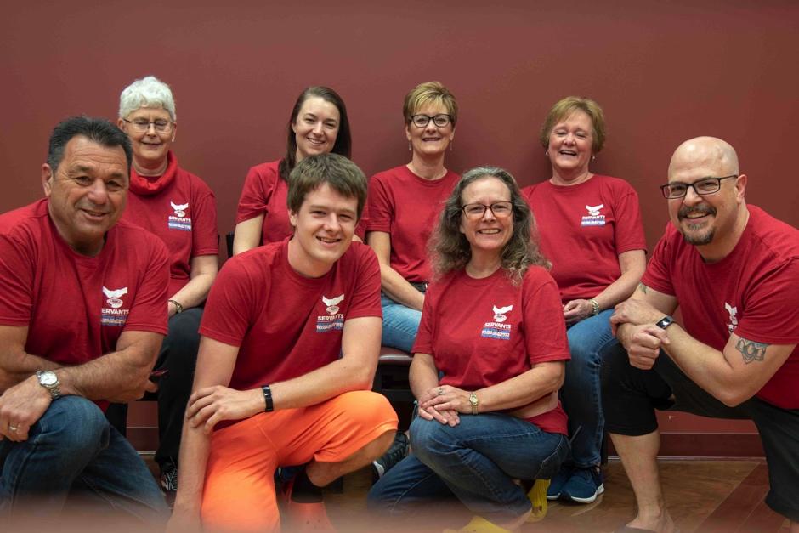

The majority of our time and focus in April and May was dedicated to the team that came to serve alongside us. They served our families in many ways! Aside from helping a family in need of a retaining wall to prevent flooding caused by the beginning of the rainy season here, they also hosted a 15 year old birthday party, planned a mother’s day activity, and spent time with almost every family taking pictures of them that were gifted to all the mothers! Their time here not only refreshed us, but boosted our relationship and impact on the community and families we serve.

If you’ve tuned into our VLOG, you will already know the difficulties we have experienced with stomach illness this past month. Thank you for your prayers! Dylan is better and Missy is recovering.

These coming months will bring more focus to developing the ministry. While Missy continues to focus hard on her studies while finding balance in caring for the 7 at-risk families she is responsible for, Dylan will be working more on the executive level at Servants. We are slowly developing a curriculum for staff as well as the community to grow in leadership, personal development, and service with a specialization in empowering the poor. Additionally, we will be trying to increase our impact through media such as informational video lessons and systems development to increase the effectiveness of our ministry team.

We will also be working on new fundraising initiatives to raise more resources that are needed for the SARF ministry!

Missy achieved another A in her last class and maintains a 4.0 GPA

#### **Prayer**

For Missy’s continued recovery from the stomach illnesses we contracted in the beginning of May.

Energy, wisdom, and discernment as God leads us to “what’s next” in ministry.

Guidance as we continue to disciple those whom God has put in our areas of influence.

We continue to see spiritual growth in the families we serve. He has been gracious to reveal fruits of our labor.

We had a WONDERFUL time with our team that came down in May to serve with us.

##### Matthew 5:45

# For He causes His sun to rise on the evil and the good and sends rain on the righteous and the unrighteous

#### **Praise**

### Prayers & praises

## Have you heard of our VLOG?

In an effort to keep our friends and family more connected to our ministry on a regular basis, we started a weekly VLOG (video blog) which chronicles things we experience on a daily basis. Usually we get the question, “what’s a normal day look like in ministry?” to which we rarely have a good response because there is no typical, normal day. We have been publishing the episodes weekly through our blog but are accessible on our YouTube page as well. Many of you have already expressed enthusiasm over them. If you haven’t already, we encourage you to check out our **YouTube** or **Facebook** page (search Uniting 2 Serve) and subscribe for the updates!

April Flowers, May Showers

We feel overly privileged to be able to serve others in the way God has called us to according to our gifts and passions. However, ministry isn’t as easy or glamorous as it seems many times and can really test us in our resolve to follow God’s purpose for our lives.

We are eternally grateful to have all of you, our faithful prayer partners, financial supporters, family, and friends behind us encouraging us the whole way. Thank you for being the blessing you are!

**Love,  
The Brobsts**

Dylan and his friend Josh just launched their podcast that has been in the works for almost a year. Check out **realchurchtalk.com** to subscribe and share!

We are blessed by your continued prayers, love, and encouragement!

## May the peace of God bless you always.

## Regardless of the difficulty, we keep pressing on toward the goal.